S I S Science

Class: Grade 6

Topic: Types of rocks

**What is a rock?**

A rock is a natural solid material made up of one or more minerals that forms part of the Earth's crust. Geologists are scientists who study rocks.

**Types of rocks**

There are three main types of rocks:

1. Igneous Rocks: Rocks formed from cooled and solidified magma or lava.

2. Sedimentary Rocks: Rocks formed from compressed layers of sediment.

3. Metamorphic Rocks: Rocks formed when existing rocks are changed by heat and pressure.

**Examples of rocks**

Common examples of different types of rocks:

1. Igneous Rocks:

Granite – They are often seen in countertops and buildings.

Basalt – They are found in volcanic areas, like lava flows.

Pumice – They are light, airy rock that floats on water, formed from volcanic eruptions.

2. Sedimentary Rocks:

Limestone – They are used in making cement, often found in caves.

Sandstone – They are made from compacted sand, commonly used in building materials.

Shale – They are soft rock that can break into thin layers, often found in riverbeds.

3. Metamorphic Rocks:

Marble – They are known for its use in statues and buildings, formed from limestone.

Slate – They are used in roofing and blackboards, formed from shale.

Schist – They are shiny rock with visible layers, found deep in the Earth's crust.

**Characteristics** **of the three types of rocks**

**1. Igneous Rocks**

They are hard and durable.

They often have a crystalline texture.

They may appear shiny or glassy.

They do not contain fossils.

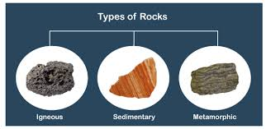

**2. Sedimentary Rocks**

They have distinct layers.

They are softer and can crumble easily compared to igneous rocks.

They may contain fossils of plants or animals.

They are formed from grains or particles.

**3. Metamorphic Rocks**

They are hard and dense.

They may have bands or wavy patterns.

They can have large or small crystals.

They do not usually contain fossils due to heat and pressure.

**Note:** Fossils are the remains or traces of plants, animals, or other living things that lived long ago and got preserved in rocks.Fossils form when these remains are buried by layers of dirt and rock over time.

2nd Term Week 1 Class Note

S I S Science

Class: Grade 6

Topic: Formation of Igneous rock

**Igneous rock**

The word 'Igneous' means fire**.** Igneous rocks are formed when magma (molten rock beneath the Earth's surface) or lava (molten rock on the surface) cools and solidifies.

Molten refers to a substance, usually a rock or metal, that has been melted into a liquid form due to intense heat.

**What is the difference between magma and lava?**

Magma is molten rock found beneath the Earth's surface. When magma reaches the Earth's surface during a volcanic eruption, it is called lava.

**How are igneous rocks formed?**

Igneous rocks are formed when molten rock, either magma (underground) or lava (on the surface), cools and solidifies**.** This process is called solidification.

**Intrusive and extrusive igneous rocks**

* Intrusive igneous rocks form underground when magma cools slowly, creating large crystals (e.g., granite).
* Extrusive igneous rocks form on the surface when lava cools quickly, resulting in small crystals (e.g., basalt)

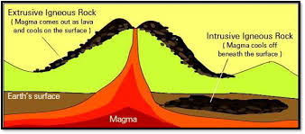**How Cooling Rates Affect Crystal Size and Rock Texture**

The rate at which magma or lava cools determines the size of crystals in igneous rocks and their overall texture:

**1. Slow Cooling (Underground):** When magma cools slowly deep beneath the Earth's surface, there is enough time for large crystals to form. This results in a coarse-grained texture, as seen in rocks like granite, where individual crystals are visible.

**2. Fast Cooling (Surface):** When lava cools quickly at or near the Earth's surface, the crystals do not have much time to form, leading to small crystals. This creates a fine-grained texture, as seen in rocks like basalt.

**3. Very Rapid Cooling:** Sometimes, lava cools so rapidly (like in water) that it forms glassy rocks like obsidian, which lacks visible crystals.

**Real-Life Applications of Igneous Rocks:**

**1. Granite:** **Construction:** Used for countertops, building facades, and monuments due to its durability and aesthetic appeal.

**2. Basalt:** **Road Construction:** Basalt is commonly crushed and used in construction materials like asphalt for roads and highways.

**3. Pumice:** **Industrial Applications:** Pumice is used as an abrasive material in products like exfoliating skin care products, cleaning agents, and in polishing compounds**.**

1. **Obsidian:** **Cutting Tools:** Due to its sharp edges, obsidian was historically used for making cutting tools, knives, and arrowheads by ancient civilizations**.**

2nd Term Week 2 Class Note

S I S Science

Class: Grade 6

Topic: Formation of Sedimentary rocks

Sedimentary rocks are formed through the processes of weathering, erosion, and sedimentation:

**1. Weathering**: Rocks break down into smaller pieces through physical, chemical, or biological processes.

**Types of weathering are:**

Physical Weathering: The breakdown of rocks into smaller pieces without changing their chemical composition. For example, rocks can break due to temperature changes or freezing and thawing of water inside cracks.

Chemical Weathering: The breakdown of rocks due to chemical reactions. For example, rainwater, which is slightly acidic, can dissolve minerals in rocks.

Biological Weathering: The breakdown of rocks caused by biological activity, such as the growth of plant roots that crack rocks or the actions of animals like burrowing.

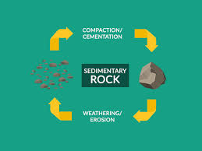

**2. Erosion:** Weathered particles are transported by natural forces like wind, water, and ice to new locations.

**3. Sedimentation:** The transported particles settle in layers over time. These layers are compacted by the weight of overlying materials, and pressure causes them to harden, eventually forming sedimentary rocks.

**Fossilization and Fossils in Sedimentary Rocks**

Fossils are the remains of organisms preserved in sedimentary rocks. The process of fossilization happens in several steps:

1. Death and Burial: The organism’s remains are quickly covered by layers of sediment.

2. Compression: As more layers build up, pressure is applied to the buried remains, compressing them.

3. Mineralization: Over time, minerals replace the organic materials, turning the remains into fossils.

4. Formation of Fossils: After mineralization, the organism’s remains are preserved as a fossil, typically within a layer of sedimentary rock.

**Role of Fossils in Sedimentary Rocks**

Fossils are preserved in sedimentary rocks because these rocks form through the accumulation and compression of sediment layers. As organisms are buried by sediment, they undergo fossilization. Fossils in these rocks provide valuable insights into past life and environments, offering evidence of ancient species and ecosystems.

2nd Term Week 3 Class Note

S I S Science

Class: Grade 6

Topic: Formation of Metamorphic rocks

**How Heat and Pressure Work Together to Form Metamorphic Rocks**

Heat from deep within the Earth, primarily from magma, causes the minerals in existing rocks to recrystallize. This leads to a change in the texture and structure of the rock.

Pressure comes from the weight of the overlying rocks and tectonic forces. As rocks are buried deeper in the Earth, the pressure causes the minerals to align or become compressed, changing the rock's composition.

Together, heat and pressure cause the minerals in the rock to rearrange, forming a denser and more crystalline metamorphic rock.

**Formation of Each Type of Metamorphic Rock**

There are two main types of metamorphic rock:

1.Foliated Metamorphic Rocks: These rocks form under directional pressure, causing the minerals to align in layers or bands.Examples:

Slate: Formed from shale under low heat and pressure.

Schist: Formed from shale with higher heat and pressure.

Gneiss: Formed from granite or shale under intense heat and pressure.

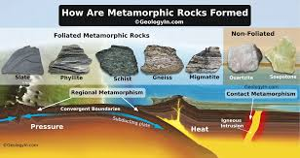

2. Non-Foliated Metamorphic Rocks:

These rocks form under uniform pressure, where minerals recrystallize but do not form layers or bands. Examples:

Marble: Formed from limestone under heat and pressure.

Quartzite: Formed from sandstone under heat and pressure.

**Real-life Examples of Metamorphic Rocks and Their Uses**

1. Marble: Used for sculptures, countertops, and flooring.
2. Slate: Used for roofing, tiles, and paving stones.
3. Quartzite: Used for countertops and tiles.
4. Gneiss: Used in decorative stonework and facades.
5. Schist: Used in ornamental stone and industrial minerals like mica

2nd Term Week 4 Class Note

S I S Science

Class: Grade 6

Topic: Rock Cycle

**Rock cycle**

The rock cycle shows how rocks change from one type to another over time. This happens through different processes like crystallization, compaction, and metamorphism, as well as natural forces such as weathering, erosion, and volcanic activity.

1. Crystallization occurs when magma or lava cools, and minerals form crystals. This process creates igneous rocks, like granite and basalt.

2. Compaction happens when layers of sediment are buried and pressed together over time, squeezing out water and air. This process forms sedimentary rocks, such as sandstone and limestone.

1. Metamorphism occurs when rocks are exposed to intense heat and pressure deep underground. This changes the structure of the rocks, forming metamorphic rocks, like marble and slate.

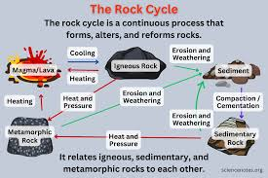

**How volcanic activity contributes to the rock cycle:**

Volcanic activity brings magma to the Earth’s surface, where it cools and solidifies into igneous rocks.

The heat from volcanic activity can cause existing rocks nearby to undergo metamorphism, turning them into metamorphic rocks.

Natural processes keep the rock cycle in motion:

Weathering breaks rocks into small pieces called sediments.

Erosion moves these sediments to new locations, like rivers and valleys.

Over millions of years, these processes repeat, transforming rocks and continuing the rock cycle.

2nd Term Week 5 Class Note

S I S Science

Class: Grade 6

Topic: Soil Composition and types

**Soil Composition**

Soil is made up of four main components: minerals, organic matter, water, and air. Minerals come from broken-down rocks, organic matter comes from dead plants and animals, water helps plants grow, and air creates space for roots and organisms.

**There are three main types of soil:**

**1. Sandy Soil** – Has large particles, feels rough, and does not hold water well. It drains quickly, making it difficult for some plants to grow.

**2.Silt soi**l - Has fine, smooth particles and retains water better than sand. It is fertile and good for farming but can compact easily.

**3. Clay Soi**l – Has tiny particles, feels smooth and sticky when wet, and holds a lot of water. However, it drains slowly, which can make it too wet for some plants.

1. **Loam Soil** – A mixture of sand, clay, and organic matter. It holds water well and provides nutrients, making it the best soil for farming and plant growth.

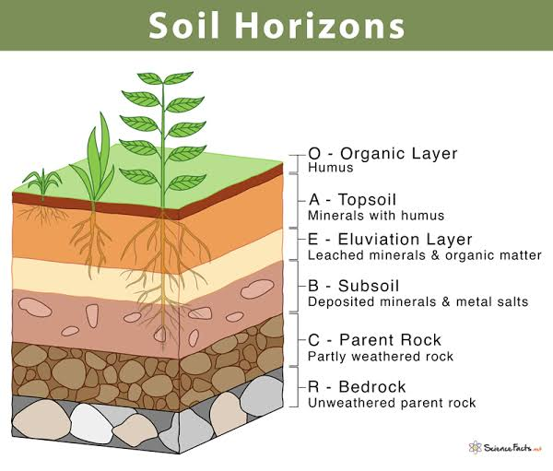**Soil Horizons**

Soil is made up of different layers, each with its own characteristics and functions. These layers are called soil horizons. There are five main soil horizons: O, A, B, C, and R.

**1. O Horizon (Organic Layer)**

The O Horizon is the topmost layer of soil, composed mainly of organic material such as leaves, twigs, and decomposed plants and animals.

Function: This layer provides essential nutrients for plants and is rich in organic matter that helps in soil fertility.

**2. A Horizon (Topsoil)**

The A Horizon is beneath the O Horizon and contains a mixture of organic material (decayed plants and animals) and minerals.

Function: This layer is often called topsoil and is the most fertile. It supports plant roots and is crucial for plant growth.

**3. B Horizon (Subsoil)**

The B Horizon lies below the A Horizon and is mostly made of mineral matter such as clay, iron, and other nutrients leached from the upper layers.

Function: It stores minerals and nutrients that are absorbed by plant roots. The B Horizon also has less organic material than the A Horizon and can be more compact.

**4. C Horizon (Parent Material)**

The C Horizon is made up of weathered parent material, such as rocks and minerals that have broken down into smaller pieces over time.

Function: It acts as the foundation from which soil forms. It may contain larger rock fragments and contributes to the mineral content of the soil.

**5. R Horizon (Bedrock)**

The R Horizon is the lowest layer, made of solid, unweathered rock. It is sometimes referred to as bedrock.

Function: The R Horizon is not often a source of nutrients for plants but provides stability and a foundation for the layers above it.

2nd Term Week 6 Class Note